1. **What is software? What is software engineering?**

**Ans:-** Software refers to a set of instructions, programs, and data that enable a computer or other electronic device to perform specific tasks or functions. such as programs and applications, as well as the intangible components, such as algorithms and data structures.

Software engineering, on the other hand, is the discipline concerned with the systematic, disciplined, and quantifiable approach to the development, operation, and maintenance of software systems. It involves applying engineering principles and practices to software development processes, aiming to ensure that software is reliable, efficient, maintainable, and scalable. Software engineering encompasses various activities, including requirements analysis, design, coding, testing, deployment, and maintenance, all aimed at delivering high-quality software products or solutions.

1. **Explain types of software?**

**Ans:- Types of software:**

1. System Software: This type of software provides a platform for running application software and manages computer hardware resources. Examples include operating systems (e.g., Windows, macOS, Linux), device drivers, and utility programs like disk management tools and antivirus software.
2. Application Software: Application software is designed to perform specific tasks or functions for end-users. It includes a wide range of programs tailored to various needs, such as word processors, spreadsheets, web browsers, email clients, graphic design software, and multimedia players.
3. Programming Software: Programming software consists of tools and applications used by software developers to create, debug, and maintain other software programs. This category includes integrated development environments (IDEs), text editors, compilers, debuggers, and version control systems.
4. Middleware: Middleware acts as a bridge between application software and system software, facilitating communication and data management across distributed systems. Examples include web servers, database management systems (DBMS), message-oriented middleware (MOM), and application servers.
5. Embedded Software: Embedded software is specifically designed to control and manage embedded systems, which are specialized computer systems embedded within larger devices or machinery. Examples include firmware in consumer electronics, automotive control systems, industrial automation, and medical devices.
6. **What is SDLC? Explain each phase of SDLC ?**

**Ans:- SDLC is a software Development life circle.**

1. Analysis:-
   * This phase involves gathering and documenting requirements from stakeholders, including clients, end-users, and other relevant parties.
   * Requirements are analyzed to ensure they are clear, complete, and feasible within the project scope and constraints.
   * The outcome of this phase is a detailed requirements specification document that serves as a roadmap for the development process.
2. System Design:
   * In this phase, the system architecture and design are developed based on the requirements gathered in the previous phase.
   * High-level and detailed designs are created, including the overall system structure, data models, user interface designs, and technical specifications.
   * Design decisions focus on achieving the desired functionality, performance, scalability, and maintainability of the software system.
3. Implementation (Coding):-
   * This phase involves actual coding or programming of the software based on the design specifications.
   * Developers write code according to coding standards and best practices, using appropriate programming languages, frameworks, and tools.
   * Unit testing may also be performed during this phase to verify the correctness of individual components or modules.
4. Testing & intigration:-
   * The testing phase involves verifying and validating the software to ensure that it meets the specified requirements and quality standards.
   * Different types of testing, such as functional testing, integration testing, performance testing, and usability testing, are conducted to identify defects and ensure the reliability and usability of the software.
   * Test cases are designed, executed, and documented, and defects are reported and tracked for resolution.
5. Maintenance:-
   * The maintenance phase involves ongoing support and maintenance activities to address issues, fix defects, and incorporate enhancements or updates to the software.
   * Maintenance tasks may include bug fixes, performance optimizations, security patches, and feature enhancements based on user feedback and changing requirements.
   * Support services are provided to address user inquiries, troubleshoot issues, and ensure the continued functioning of the software in production environments.
6. **What is DFD? Create a DFD diagram on Flipkart**

**Ans:-**DFD stands for Data Flow Diagram. It is a graphical representation of the flow of data through a system or process. DFDs are commonly used in software engineering and systems analysis to model the structure and behavior of systems in terms of inputs, processes, data stores, and outputs.

Creating a DFD diagram for a complex system like Flipkart, which is an e-commerce platform

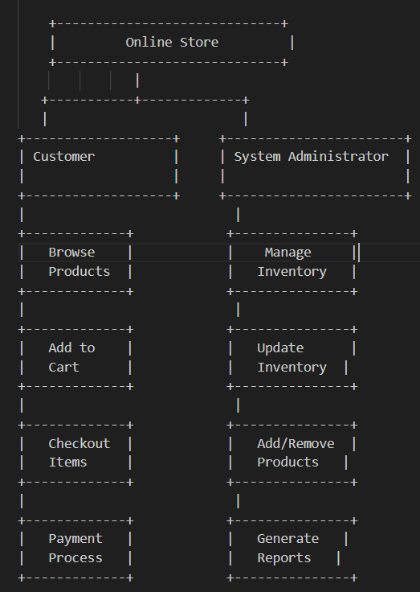

In this simplified DFD diagram:

* The "Online Store" represents the e-commerce platform.
* "Customer" interacts with the system by browsing products, adding them to the cart, and checking out items.
* "System Administrator" manages inventory, adds or removes products, and generates reports.
* Data flows between various processes such as browsing products, managing inventory, processing payments, etc.

1. **What is Flow chart? Create a flowchart to make addition of two numbers**

**Ans:-** flow chart is a step by step soultaion of any program and problem.

Start

|

V

Input first number (A)

|

V

Input second number (B)

|

V

Add A and B

|

V

Output result

|

V

End

* "Start" and "End" indicate the beginning and end of the process, respectively.
* "Input first number (A)" and "Input second number (B)" represent the steps where the user inputs the two numbers to be added.
* "Add A and B" denotes the step where the addition operation is performed on the input numbers.
* "Output result" indicates the step where the result of the addition operation is displayed or output to the user.

1. **What is Use case Diagram? Create a use-case on bill payment on paytm.**

**Ans:-** case diagram is a graphical representation of the interactions between a system (the subject) and its external actors (users or other systems), illustrating the various ways the system can be used to achieve specific goals or tasks. It helps in understanding the functional requirements of a system from the perspective of its users.

* **Create a use-case on bill payment on paytm.**

